**Assignment-8**

**1. Define a structure that can describe a hotel.**

**CODE:**

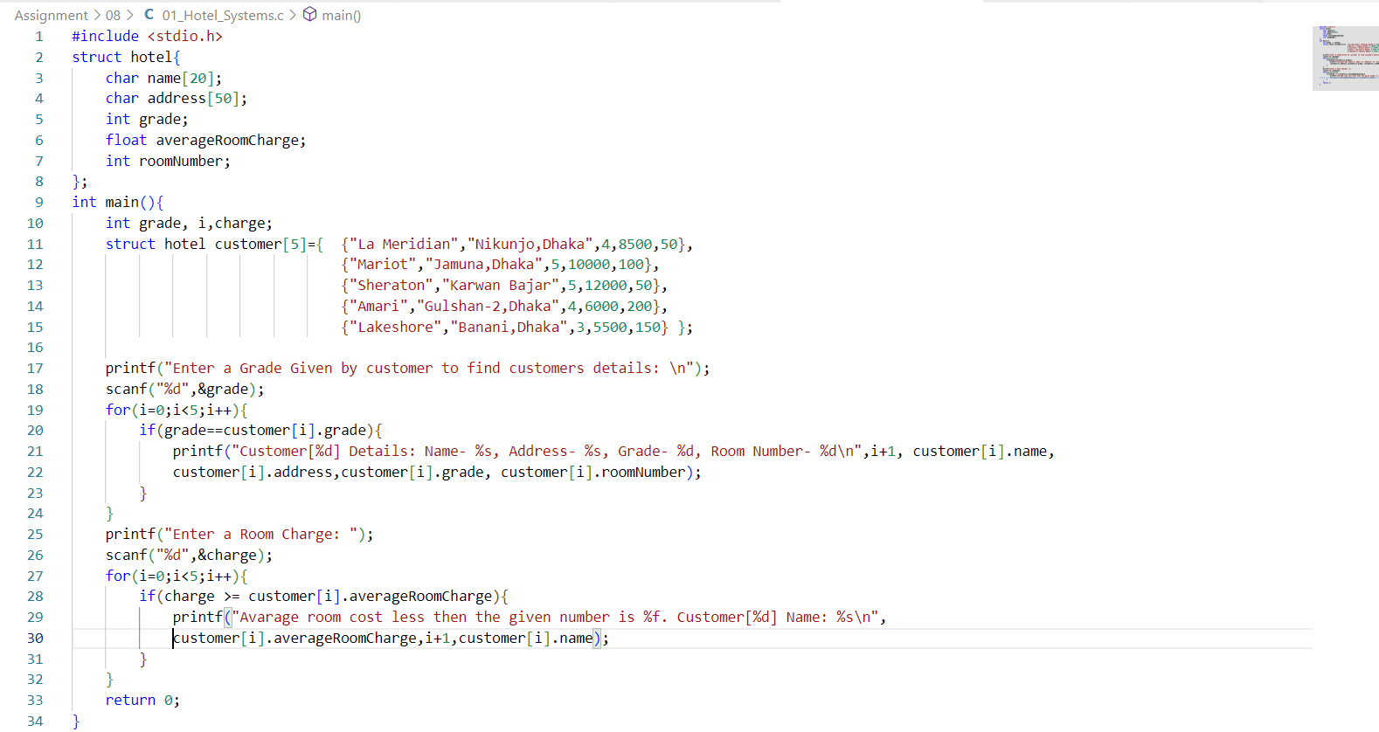

**OUTPUT:**

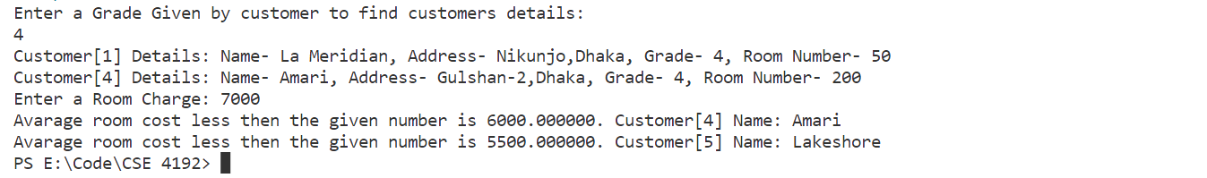

**2.** **Write a Program to Calculate Difference Between Two Time Periods using structure.**

**CODE:**

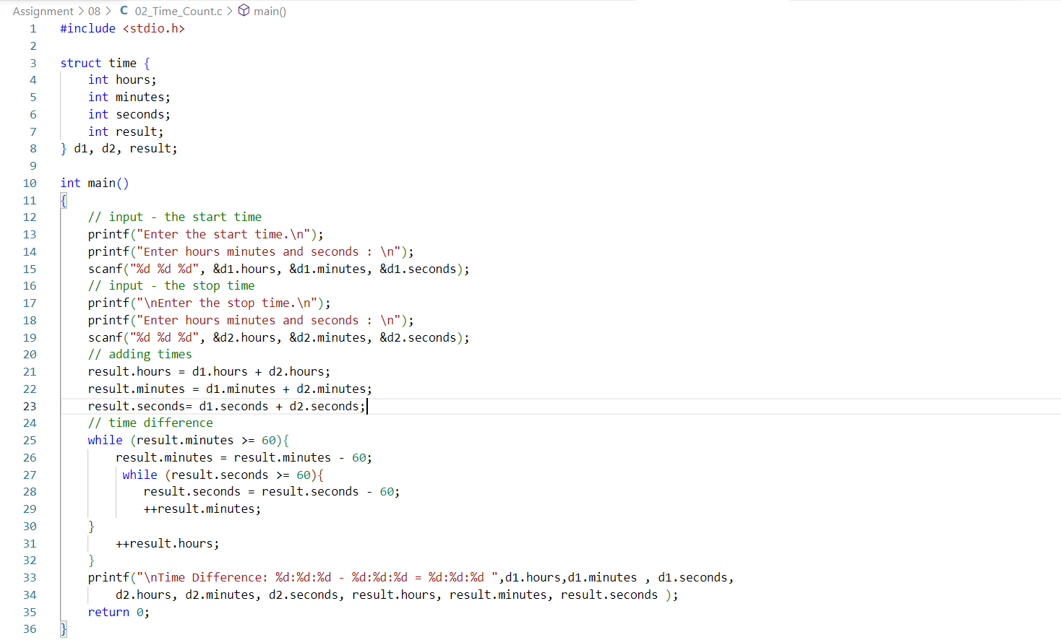

**OUTPUT:**

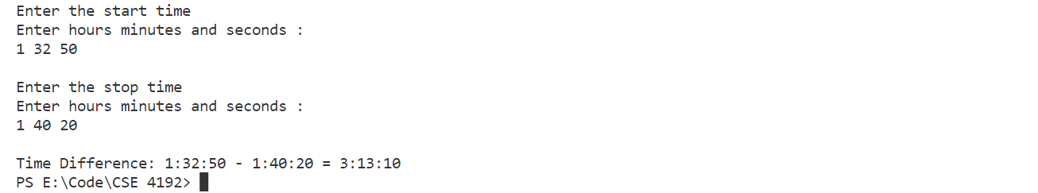

**LAB WORK-8**

**1. Write a C program to find difference between feet and inch.**

**CODE:**

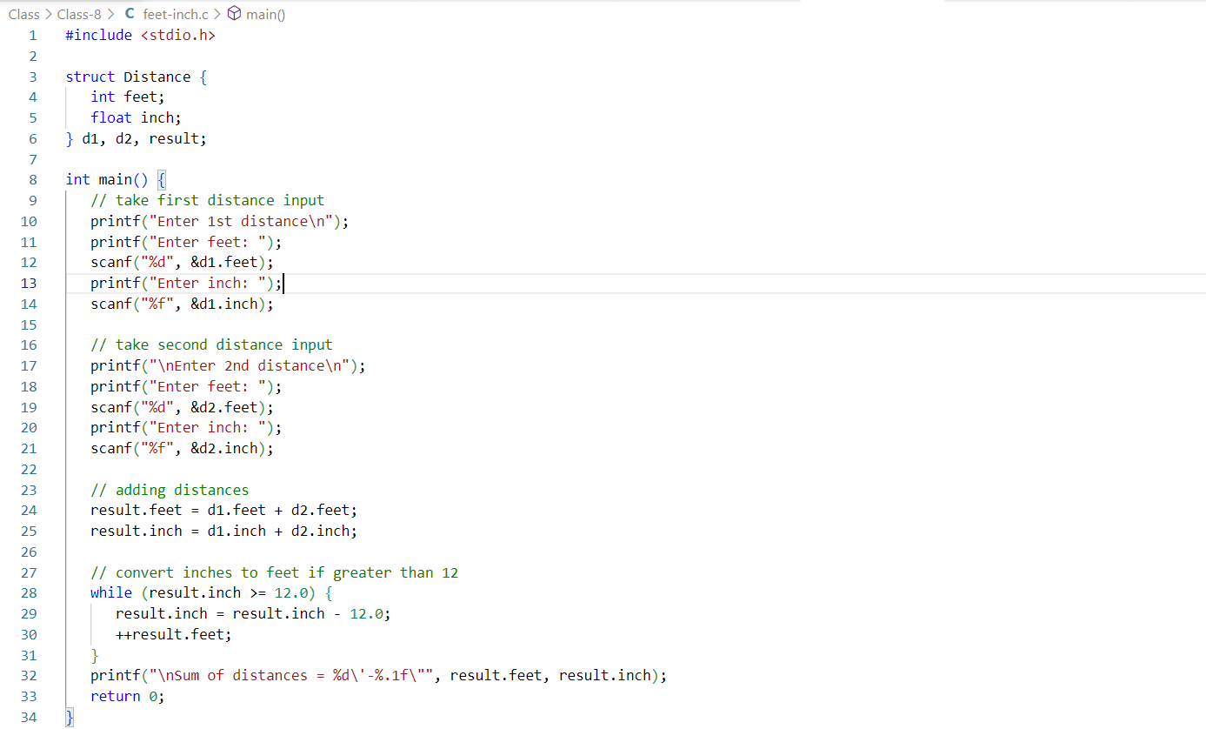

**OUTPUT:**

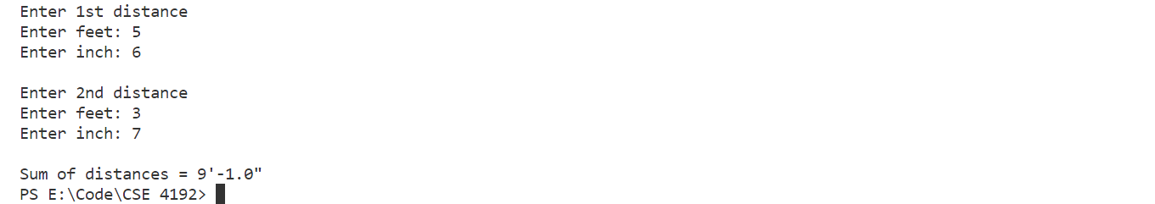

**2. Write a C program to take Student information from the user and show output using structure.**

**CODE:**

